**Project Design Phase-I**

**Solution Architecture**

| Date | 10 October 2023 |
| --- | --- |
| Team ID | NM2023TMID07501 |
| Project Name | Unleashing the Potential of Our Youth: A Student Performance Analysis |
| Maximum Marks | 4 Marks |

**Solution Architecture:**

∙ Our solution is a student performance analysis tool that uses data analytics to analyze the performance of students. The tool collects data from various sources such as exam results, attendance records, and student feedback, and uses this data to generate insights into the performance of students. The tool provides dashboards and reports that help teachers and educational institutions to identify the areas where students are struggling and take corrective measures to improve their performance.

∙ Our solution is unique because it uses data analytics to analyze the performance of students. Our solution is also unique because it is customizable and can be tailored to the specific needs of each educational institution and provides specifications according to which the solution is defined, managed, and delivered.

**Example - Solution Architecture Diagram:**

**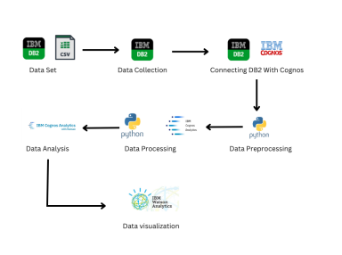***Figure 1: Architecture and data flow of a Student Performance Analysis application* **Reference:** https://www.jetir.org/papers/JETIR2009095.pdf